Bowls Manawatu Woman's Open Triples Winners
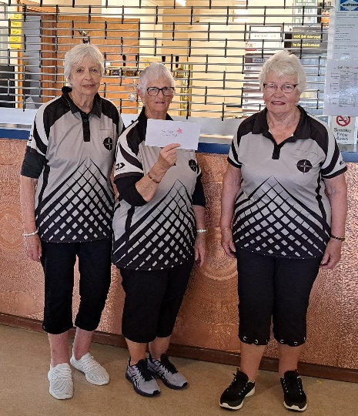
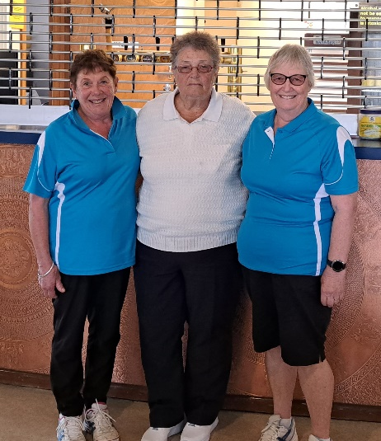
First Place: Second Place:
M Fryer / K Hill / J Noble H Giblett / E Goldsworthy / C Roughan

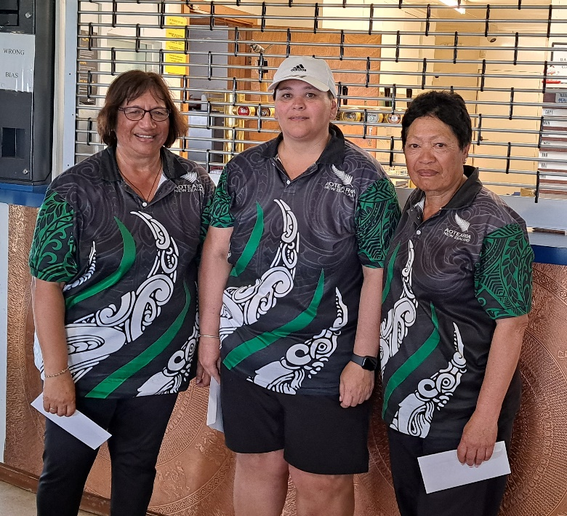
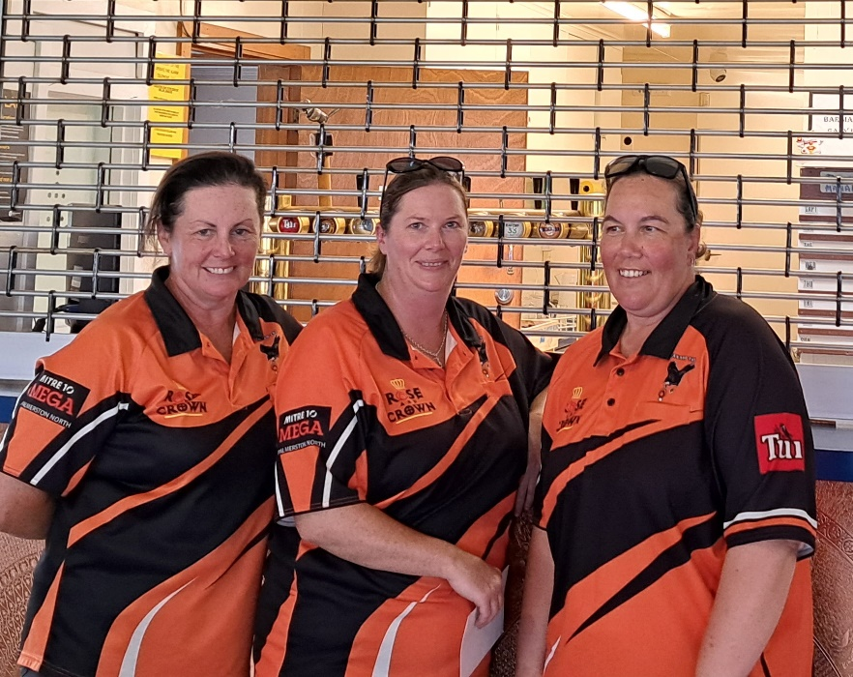

Third Equal: C Davidson / V Lozell / N Elston from North End and F Jones / B England /Jen Brown Composite Team

